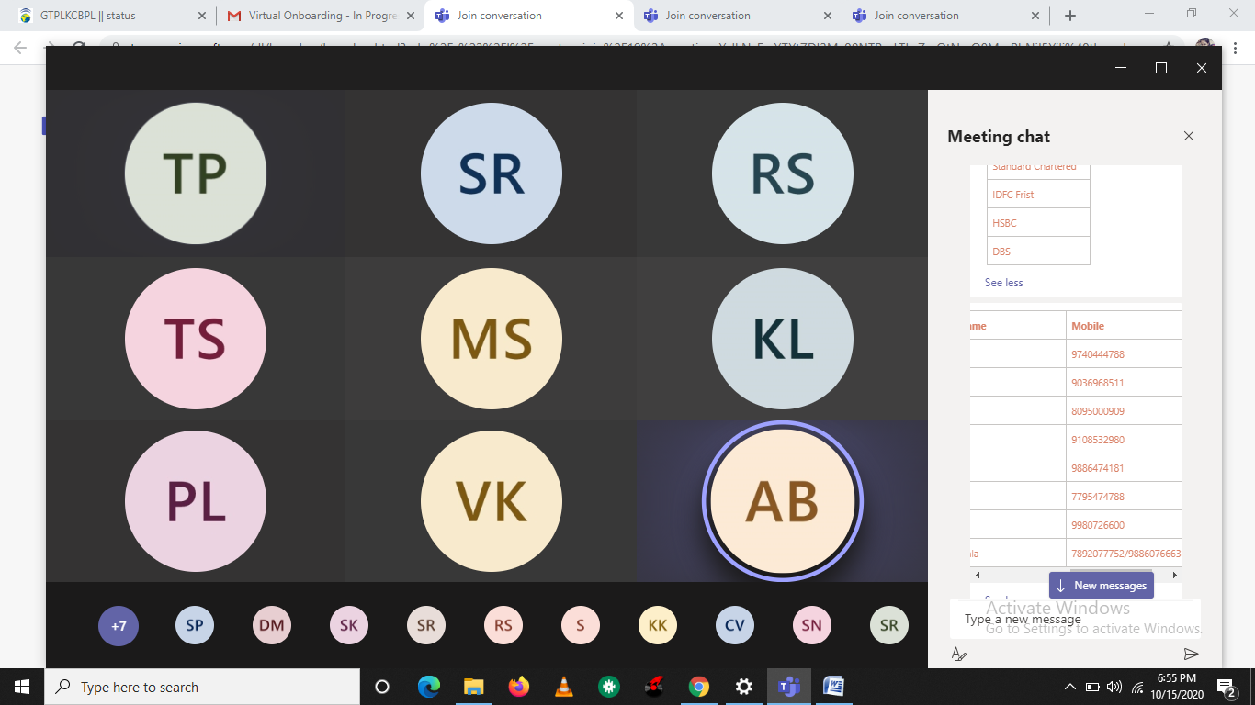

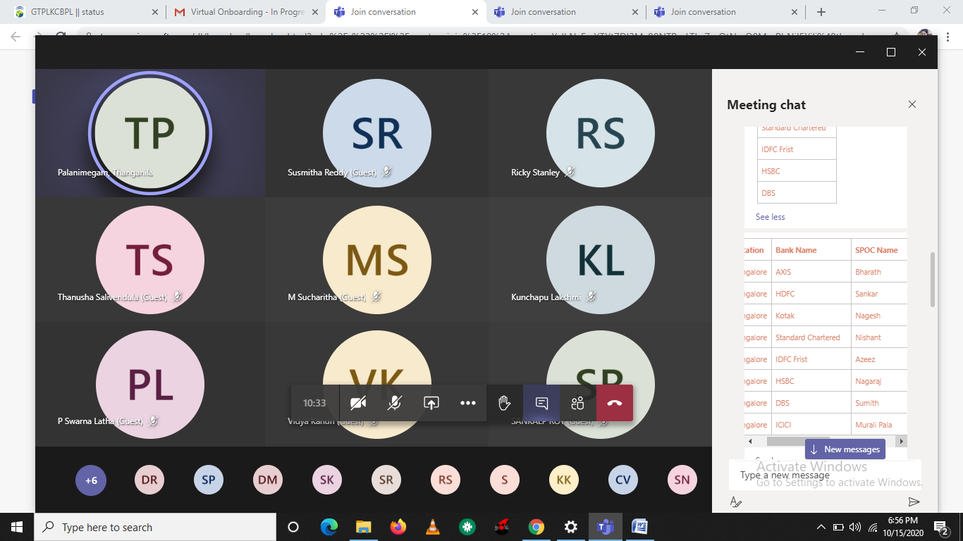

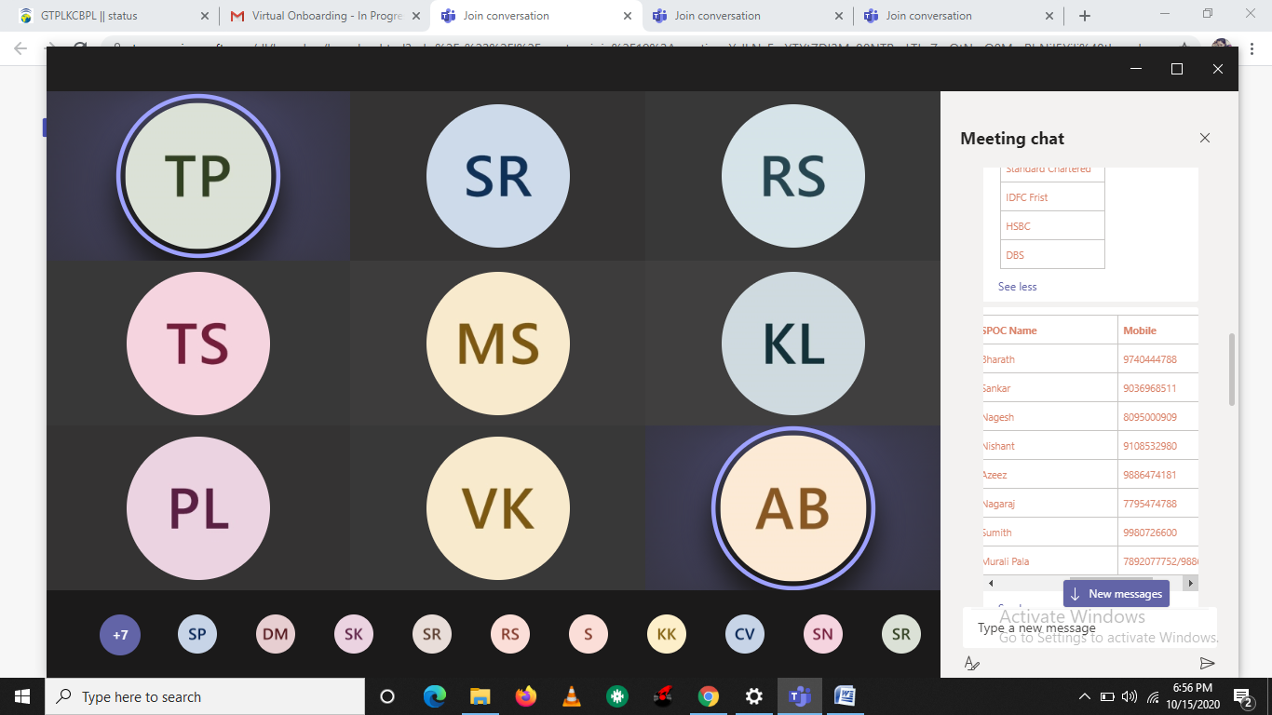

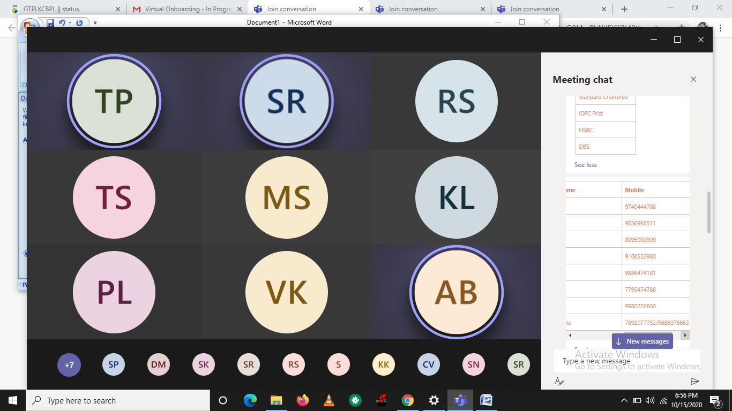

**Intranet Portal :** [http://talent.capgemini.com/in](http://talent.capgemini.com/in" \t "_blank" \o "http://talent.capgemini.com/in)

**HR Portal : Myconnect**

**Pathway:** Talent ([https://talent.capgemini.com/in](https://talent.capgemini.com/in" \t "_blank" \o "https://talent.capgemini.com/in)) >>Access All>>MyConnect

**→ Salary & Reimbursement Account Details Updation:**

[Talent page](https://talent.capgemini.com/in/" \t "_blank" \o "https://talent.capgemini.com/in/) > [MyConnect](https://myc-capgemini.neocaseonline.com/default.aspx?pageid=1471" \t "_blank" \o "https://myc-capgemini.neocaseonline.com/default.aspx?pageid=1471) >> Access Your Personal Data (ESS) >> Employee Self Service >> Personal Information >> Personal Profile >> View / Update Bank details

Talent ([https://talent.capgemini.com/in](https://talent.capgemini.com/in" \t "_blank" \o "https://talent.capgemini.com/in)) >>Access All>>MyConnect>>Access your Personal Data(ESS)>>Personal Information>>Personal Profile>>View/update Personal Information

**→ PAN & Adhaar number Updation:**

Path: Talent ([https://talent.capgemini.com/in](https://talent.capgemini.com/in" \t "_blank" \o "https://talent.capgemini.com/in)) >>Access All>>MyConnect>>Access your Personal Data(ESS)>>Personal Information>>Personal Profile>>View/update National ID

Path: Talent ([https://talent.capgemini.com/in](https://talent.capgemini.com/in" \t "_blank" \o "https://talent.capgemini.com/in)) >>Access All>>MyConnect>>Access your Personal Data(ESS)>>Personal Information>>Personal Profile>>View/update dependent information

**→Dependent Details Updation :**

**Path :** Talent ([https://talent.capgemini.com/in](https://talent.capgemini.com/in" \t "_blank" \o "https://talent.capgemini.com/in)) >>Access All>>MyConnect>>Access your Personal Data(ESS)>>Personal Information>>Personal Profile>>View/update dependent information

If you face issue any in updating above details pls connect Query: reach to **[hrssedm.in@capgemini.com](mailto:hrssedm.in@capgemini.com" \t "_blank" \o "mailto:hrssedm.in@capgemini.com)**

* 1. Employee id
  2. User id, Capgemini email id

il id

For any System/IT related issues/Concerns: You can call at 02267557744 or you can raise ticket at Service central portal through Intranet or you can write to [ithelp.global@capgemini.com](mailto:ithelp.global@capgemini.com" \t "_blank" \o "mailto:ithelp.global@capgemini.com) email id.

[6:56 PM] Palanimegam, Thanganila (Guest)

**Intranet Portal :** [http://talent.capgemini.com/in](http://talent.capgemini.com/in" \o "http://talent.capgemini.com/in)

**HR Portal : Myconnect**

**Pathway:** Talent ([https://talent.capgemini.com/in](https://talent.capgemini.com/in" \o "https://talent.capgemini.com/in)) >>Access All>>MyConnect

**→ Salary & Reimbursement Account Details Updation:**

[Talent page](https://talent.capgemini.com/in/" \o "https://talent.capgemini.com/in/) > [MyConnect](https://myc-capgemini.neocaseonline.com/default.aspx?pageid=1471" \o "https://myc-capgemini.neocaseonline.com/default.aspx?pageid=1471) >> Access Your Personal Data (ESS) >> Employee Self Service >> Personal Information >> Personal Profile >> View / Update Bank details

Talent ([https://talent.capgemini.com/in](https://talent.capgemini.com/in" \o "https://talent.capgemini.com/in)) >>Access All>>MyConnect>>Access your Personal Data(ESS)>>Personal Information>>Personal Profile>>View/update Personal Information

**→ PAN & Adhaar number Updation:**

Path: Talent ([https://talent.capgemini.com/in](https://talent.capgemini.com/in" \o "https://talent.capgemini.com/in)) >>Access All>>MyConnect>>Access your Personal Data(ESS)>>Personal Information>>Personal Profile>>View/update National ID

Path: Talent ([https://talent.capgemini.com/in](https://talent.capgemini.com/in" \o "https://talent.capgemini.com/in)) >>Access All>>MyConnect>>Access your Personal Data(ESS)>>Personal Information>>Personal Profile>>View/update dependent information

**→Dependent Details Updation :**

**Path :** Talent ([https://talent.capgemini.com/in](https://talent.capgemini.com/in" \o "https://talent.capgemini.com/in)) >>Access All>>MyConnect>>Access your Personal Data(ESS)>>Personal Information>>Personal Profile>>View/update dependent information

If you face issue any in updating above details pls connect Query: reach to **[hrssedm.in@capgemini.com](mailto:hrssedm.in@capgemini.com" \o "mailto:hrssedm.in@capgemini.com)**

​

[6:56 PM] Palanimegam, Thanganila (Guest)

|  |  |  |  |
| --- | --- | --- | --- |
| **Location** | **Bank Name** | **SPOC Name** | **Mobile** |
| Chennai | AXIS | Sasikumar | 9962229626 |
| Chennai | HDFC | Neelakandan | 9176644000 |
| Chennai | ICICI | Arun | 8667047133 |
| Chennai | Kotak | Raj Mohan | 9884511996 |
| Chennai | Standard Chartered | Premnath | 9600050003 |
| Chennai | IDFC Frist | Rajesh kumar | 9885125886 |
| Chennai | HSBC | N/A | N/A |
| Chennai | DBS | Sandhya Bodapati | 9952061205 |

|  |  |  |  |
| --- | --- | --- | --- |
| **Location** | **Bank Name** | **SPOC Name** | **Mobile** |
| Bangalore | AXIS | Bharath | 9740444788 |
| Bangalore | HDFC | Sankar | 9036968511 |
| Bangalore | Kotak | Nagesh | 8095000909 |
| Bangalore | Standard Chartered | Nishant | 9108532980 |
| Bangalore | IDFC Frist | Azeez | 9886474181 |
| Bangalore | HSBC | Nagaraj | 7795474788 |
| Bangalore | DBS | Sumith | 9980726600 |

[8:01 PM] PRATEECHI, VELENENI (Guest)

02267557744--->IT help desk number

​

[8:01 PM] PRATEECHI, VELENENI (Guest)

**onboarding.in@capgemini.com**

[8:01 PM] PRATEECHI, VELENENI (Guest)

**[https://talent.capgemini.com/in](https://talent.capgemini.com/in" \o "https://talent.capgemini.com/in)**

​

[8:01 PM] PRATEECHI, VELENENI (Guest)

mpass/safenet pass code(app need to download)

[8:03 PM] PRATEECHI, VELENENI (Guest)

My connect---> Access your personal data--->personal info---->personal profile

​

[8:03 PM] PRATEECHI, VELENENI (Guest)

View/update bank details

[8:03 PM] PRATEECHI, VELENENI (Guest)

Empusle----> manual attendance

​Manual attendance:-

[8:03 PM] PRATEECHI, VELENENI (Guest)

Attendance---->request--->self manual attendance

​

[8:03 PM] PRATEECHI, VELENENI (Guest)

ADD

[8:05 PM] PRATEECHI, VELENENI (Guest)

Medibuddy

​

[8:05 PM] SAI TEJA NULA (Guest) joined the meeting.

​

[8:05 PM] PRATEECHI, VELENENI (Guest)

Service central---->technical help desk

​

[8:05 PM] PRATEECHI, VELENENI (Guest)

[ithelp.global@capgemini.com](mailto:ithelp.global@capgemini.com" \o "mailto:ithelp.global@capgemini.com)

AllSec---->PF

**cgretirals@allsectech.com**

**: 022- 62491100 (Monday – Saturday, Between 08:00 AM to 08:00 PM**

Degreed platform for self learning

